Feature Demonstrations
Below is a breakdown of all functionality implemented in the network-emulator project.

Sequence & Acknowledgment Numbers
Sequence numbers are implemented with hard-coded values starting at 500 on the server side, and 0 on the client side. Sequence numbers are incremented based on the size of the data it is carrying which is counted by number of characters. The emulator uses single repeat style of acknowledgments where every packet is acknowledged, and every packet in the window has a timer. Duplicate Acknowledgements are noted in the emulator but are simply dropped as the window size settings are static in the simulation

Sequence Numbers from the Client Side
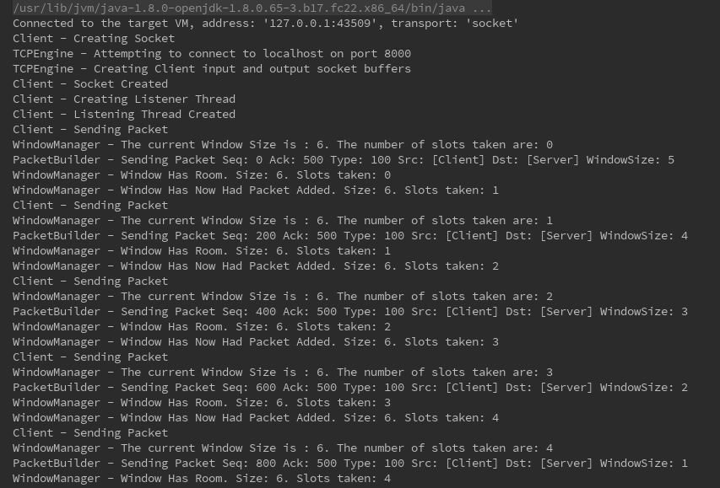

Sequence Number & Acknowledgement Numbers Returned on the Server Side
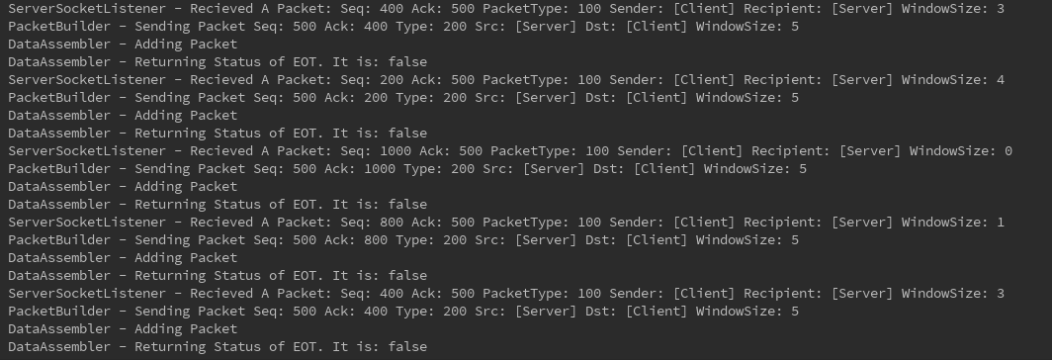

Acknowledgements Returned to The Client
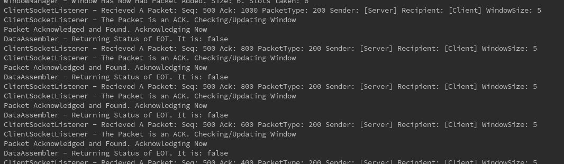

Duplicate Acknowledgement Recieved By the Server when sending Data to the Client
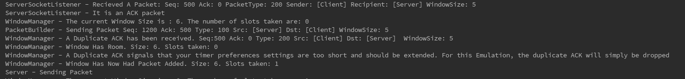

Timers & Timeouts
Timers are used on the sending side to determine when to re-transmission. The timers increment exponentially when they are triggered.

Timeouts Occurring on the Client Side
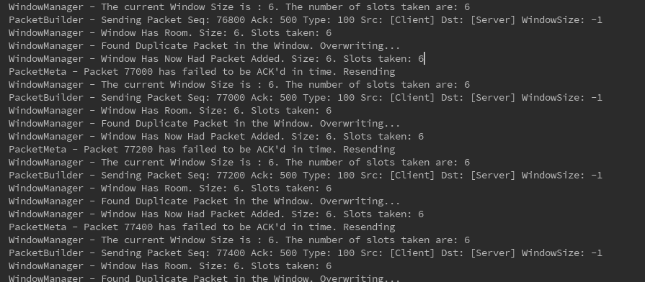

Window Size
Window size is statically enforced at the beginning of the simulation. The window size is not adjusted through the transaction. The window size is used on the sender side to control how many packets can send at the same time. If the window is full, the sending side can not send it is blocked and must wait to try again. The simulator here will sleep for 600ms before retrying again

The Window Full on the Client Side
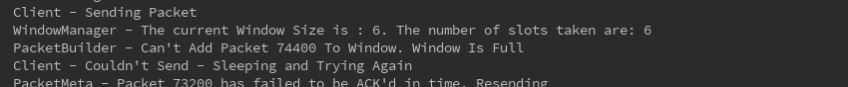

Packet Drop & Packet Delay
The simulator will drop and delay packets based on parameters passed at inialization. The BER parameter will adjust the Bit Error Rate in a percent which is calculated into a probably as to whether to drop a given packet. The Average Packet delay sets the mean packet delay in ms that is used to calculate a delay time for each packet as it travels through the emulated internet

Packet Drop on the Internet
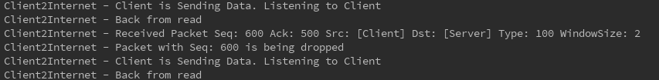

Packet Delay on the Internet
